**Lifecycle Phases**

**Mounting (Initial Render)**

* The component instance is created and rendered for the first time.
* Fresh state and props are created, akin to the component being "born".

**Re-Rendering**

* The component can be re-rendered multiple times.
* Triggers for re-rendering include state updates, changes in props, parent component re-rendering, or context changes.
* This phase is optional and doesn’t happen for all components.

**Unmounting**

* The component instance is removed and destroyed, along with its state and props, akin to the component "dying".
* Occurs when users navigate away from the component or close the app.

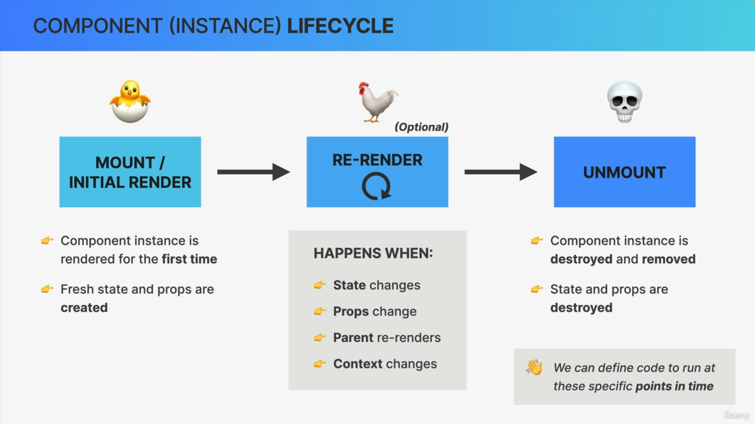

**Importance of Lifecycle Understanding**

* Knowing the lifecycle allows developers to hook into different phases.
* This is done using the useEffect Hook, enabling execution of code at specific lifecycle points.